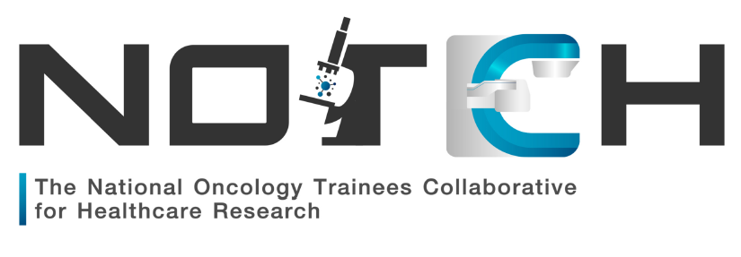
NOTCH Virtual Research Symposium
18th October 2020
9.30am – 10.00am | NOTCH Introductory Talk  Where we are today, past and present projects, project proposal process, how to get involved  Dr Anna Olsson-Brown
10.00am – 10.45am | A Taste of the Research World  How it all works, the infrastructure of research in the UK, ‘key players’ in the field of research and how they interact. How laboratory-based research is transferred into the clinical setting. How much does it all cost?  Prof Ruth Plummer
10.45am - 11.00am | COFFEE
11.00am – 11.45am | Clinical Trials Masterclass  Everything you need to know about managing trials patients day to day – consent, mandatory reviews, navigating protocols and trials reporting  Dr Natalie Cooke
11.45am – 12.30pm | Statistics for the every day  Understanding stats, what the trials are really telling you and applying stats to every day practice. Getting to grips with trial end-points.  Richard Jackson
12.30pm - 1.15pm | Ethics and Clinical Governance  What you need for audits through to clinical trials  Lauren Trough
1.15pm – 2.00pm | LUNCH
2.00pm - 2.15pm | Oral Abstract Presentation
 | BREAKOUT SESSIONS
2.15pm – 3.15pm | Clinical Trials in Clinical Oncology  What are the specific challenges of conducting radiotherapy trials and how can I get involved?  Prof Anthony Chalmers | Research-based career options  Covering the spectrum of clinical trial involvement from a research-based OOPE, becoming PI/CI and academic careers  Dr Samra Turajlic
3.15pm – 4.15pm | Writing for Publications  How to structure your project write-up and sell it to prospective journals  Dr Pippa Corrie | Research projects: how do I get started?  How to identify a good research project and guidance for funding applications  Dr Rebecca Lee
4.15pm – 4.30pm | Closing remarks

